Sleeping
Things to AVOID sleeping on:
1. Soft beds (such as pillow tops, memory foam, water beds, or air beds)
2. Couches, recliners, or soft furniture
3. Air pillows, water pillows, or memory foam pillows. In general, regular pillows will not work consistently, even if you stack them up
4. Sleeping on your stomach

Things to DO:
1. Sleep on a firm mattress. Recommendations for a good firm mattress is a sleep number bed with no pillow top (model C2 has no pillow top or memory foam) set at 100, or high resiliency foam (HR-50 or higher).
-General Rule for the High Resiliency Foam: if 250 lbs or less get the HR-50; if over 250 lbs get higher resiliency foam (like HR-70).
-It also recommended to use 1’’ inch thick plywood to lay on top of current box springs to support the foam mattress.
2. Use folded towels or an adjustable foam pillow.
3. For sleeping on your side, use a stack of towels/adjustable foam pillow instead of your current pillow. For starting height, make a fist with your thumb sticking out and take the measurement from the tip of your thumb to the bottom of your fist. This is about the height you want to start your stack of towels/adjustable foam pillow. Then lay down on the side you prefer. Slightly bend your knees and make sure you are on laying on the back of your shoulder and not directly on it.
-If you notice that your upper shoulder wants to roll forward, the pillow height is too low and you need to add a layer and retry.
-If you notice that your upper shoulder wants to roll backward, the pillow height is too high and you need to subtract a layer and retry.
4. For sleeping on your back, use only 1folded towel. Towel should lay under your head and neck.

Key Point: While you adjust the heights, close your eyes each time you lay your head down and then try to reopen them. As you get closer to the correct height for your body, you will notice that your eyes will feel heavier. When you find the correct height for your body, you will feel stable, you will not notice your body, and it will be difficult to open your eyes. If you have a good firm mattress and the height of your towels is correct, you will not flip or flop sides during the night and have a deep sleep.
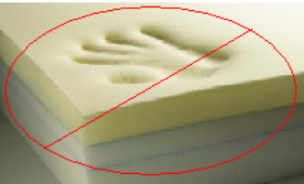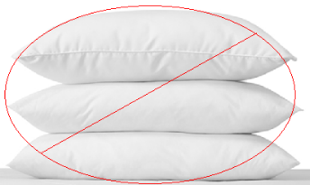
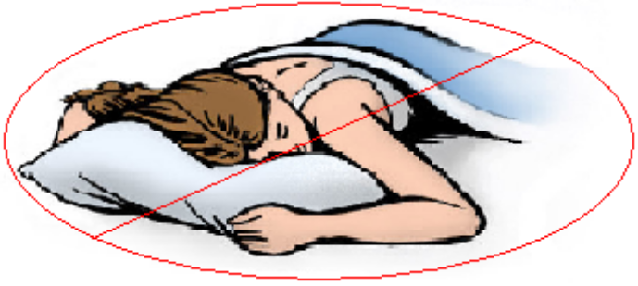

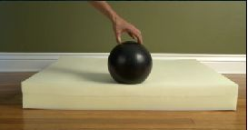

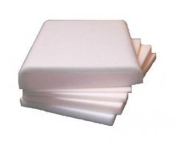

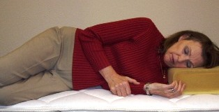

Sitting
Things to AVOID sitting on:
1. Soft chairs, soft couches, recliners, most restaurant booths, and other soft furniture
2. Anything that causes your hips to be lower than your knees
3. Wallets/Checkbooks in back pants pocket
4. Car seats that:
-slope down in the back of the seat cushion
-back rests that are not nearly upright
-lumbar supports
-headrests that protrude forward

Things to DO:
1. Sit on firm furniture. The back of the chair should be flat without curving forward or backwards.
2. Sit with hips a little higher than your knees.
- One easy way this is accomplished is by using a postural seat cushion anywhere you go (in your car, at your office, on a plane)
- This can also be accomplished by using a folded up towel and placing it in the chair or car seat
-Key Points: if using a postural cushion or even towels…
1. If it hurts your bottom or feels really hard,
it is usually too low
2. If it bothers your back, it is usually too high
3. Put wallets/checkbooks inside front pant pockets
4. Car Seats:
-Correct the seat cushion to where it is at least level to slightly higher in the back. This is accomplished by a postural cushion or towels
-Backrest needs to be nearly upright
-No lumbar supports
-Adjust your headrest if possible
5. To fix soft cushions on couches, or other furniture, we recommend high resiliency foam (HR-50 or higher). In addition, if you do not have much support under your cushion it is recommended to put about 1’’ thick plywood down to have a more solid support under your cushions.
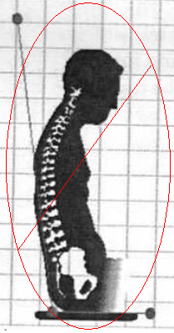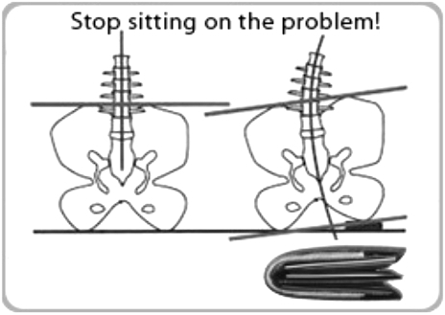
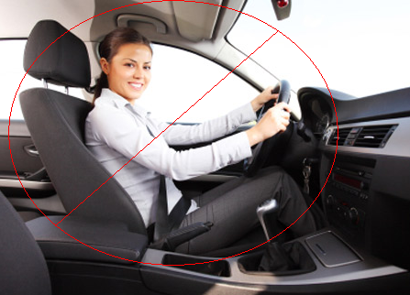

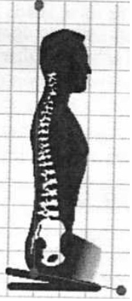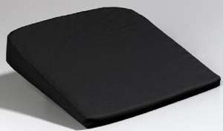
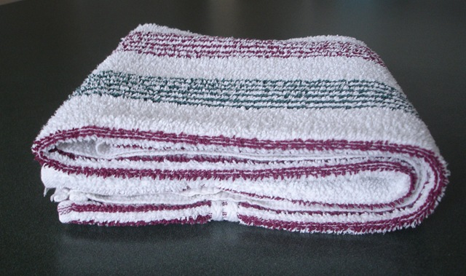

Shoe Wear
Things to AVOID with shoes:
1. Unsymmetrical shoes
2. Toes higher than your heels
3. Molded arch supports
4. Shoes that rock easily when you set them down on the floor/shelf/table
5. Rocker shoes (like Toning Shoes or Shape Up Shoes)
6. Gimmick shoes in general
7. Spring-loaded heels
8. High heels that are taller than 2 inches
9. Shoes that are rigid and not flexible
10. Insoles that cannot be removed
11. Heel cupping
12. Narrow toe box
13. Any shoe that makes your body feel less stable/balanced, makes it more difficult to take a deep breath, or makes your body collapse more forward than being barefoot.

Things to DO:
1. Make sure shoes look symmetrical
2. Heels should always be higher than toes
3. Make sure the outer sole of the shoe is as flat as possible and has no molded arch supports
4. A slight heel is preferred (about 1” for men and between 1 ½” – 2” for women)
5. Check to see if shoe rocks easily when you lay it on the floor/shelf/table
6. Bend the ends of the shoe together with your hands to evaluate flexibility
7. Check to see if insoles are flat, and if they are not, make sure they can be removed
8. With shoe inserts out, check the inside of the shoe to make sure it is flat and does not have heel cupping
9. Get shoes with a wide toe box to allow your feet to rest comfortably inside shoe when your are standing
Shoe Test: Start by standing shoeless and take a deep breath in and out, while focusing on how easy it is to breathe. Next, have a person try to push you forward with their index fingers on the back of your shoulders as you try to hold your ground. Now, try the shoes on and repeat the above tests. You have found stable shoes for your body if you can stand up without the need to shift your feet in place, and you stand in place without your body swaying. Breathing should feel the same or deeper as with no shoes on. You should also be able to hold your ground with the push test the same or better than when you had no shoes on. Walking should feel the same as shoeless.


